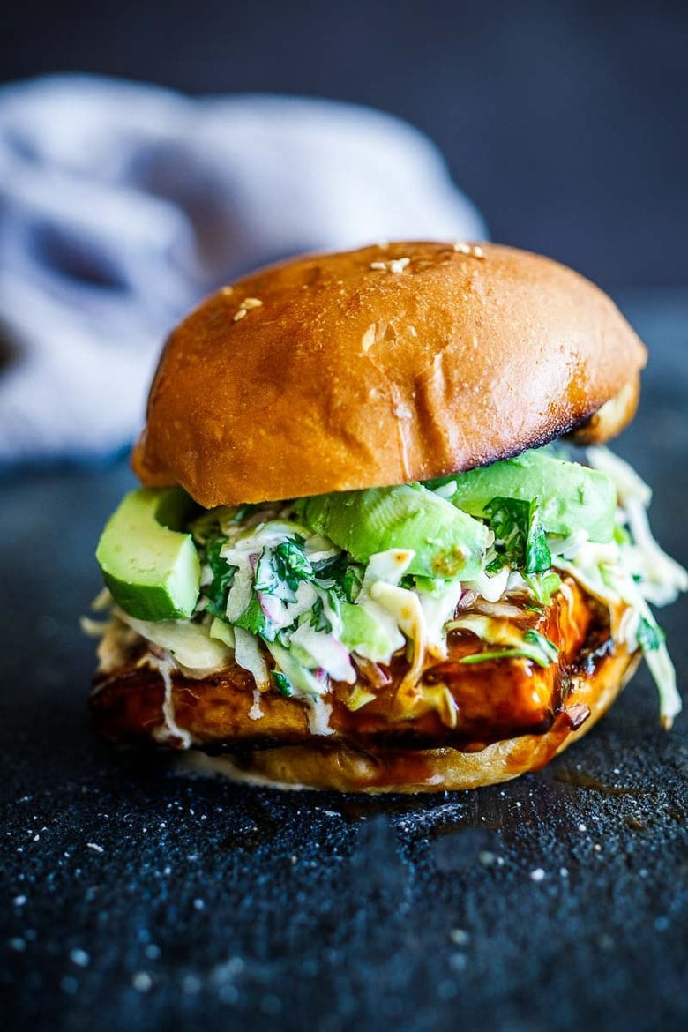
Crispy BBQ Tofu Sandwich with Slaw
DESCRIPTION:
Crispy BBQ Tofu Sandwich topped with cool, creamy cilantro cabbage slaw and avocado, that can be made in under 30 minutes. Vegan!
INGREDIENTS:
1 block tofu- organic, extra firm, drained
2 tablespoons olive oil or coconut oil
1/4 teaspoon salt
1/4 teaspoon pepper
1/4 cup BBQ Sauce (aim for one without high fructose corn syrup, or make your own)
1 teaspoon chili paste or sriracha
2 soft buns, (like brioche buns) toasted
Avocado- optional, messy but good.
4 ounces shredded cabbage- about 3 cups packed
1/4 cup cilantro, chopped
1/4 cup red onion, thinly sliced
3–4 tablespoons vegan may0 (or regular mayo) or make your own
1 tablespoon vinegar- Apple Cider or white, more to taste
1/4 teaspoon salt
INSTRUCTIONS:
Drain the block of tofu, pat dry, and cut into one-inch-thick slabs. Trim if needed to fit the bun. You can get 2, maybe 3 out of one block. Pat dry again.
Heat a skillet over medium-high heat. Add oil, and sprinkle the salt and pepper over the oil. Once the pepper is fragrant, carefully add the tofu. Sear until crispy and deeply golden- do not move it around in the pan, let it develop a crust, so it will release itself. Lower heat if splattering- this will take about 12 minutes.
Mix the BBQ sauce and red chili paste in a small bowl and set aside.
Place the shredded cabbage in a medium bowl, add onions and cilantro, mayo, vinegar, and salt, and toss to combine well. Taste. It should be creamy, tangy, and flavourful. Feel free to add more vinegar, salt or mayo to attain this. All mayos are different!
Toast the buns and slice the avocado.
Once the tofu is nice and crispy, lower the heat to low, and add the bbq sauce mixture, coating the tofu well. I use all the sauce. Let it caramelize just slightly in the pan, and turn the heat off.
Assemble the Sandwich. Spread more mayo on the bottom bun if you like, add the hot tofu, and top with cool slaw and a few slices of avocado.
EAT immediately.
NUTRITION:
Serving Size: one sandwich
Calories: 527
Sugar: 19 g
Sodium: 1128.4 mg
Fat: 30.6 g
Saturated Fat: 4.2 g
Carbohydrates: 43.2 g
Fiber: 5g
Protein: 21.6 g
Cholesterol: 0 mg

